UNITED STATES
SECURITIES AND EXCHANGE COMMISSION
WASHINGTON, D.C. 20549
Form 8-K
CURRENT REPORT
PURSUANT TO SECTION 13 OR 15(d) OF
THE SECURITIES EXCHANGE ACT OF 1934
Date of Report (Date of earliest event reported): August 7, 2026
MYR GROUP INC.
(Exact name of registrant as specified in its charter)
Delaware |  |  | 1-08325 |  |  | 36-3158643
(State or Other Jurisdiction  of Incorporation) |  |  | (Commission  File Number) |  |  | (I.R.S. Employer  Identification No.)
 |  |  | 12121 Grant Street, |  |  |  |  |  | Suite 610
 |  |  | Thornton, |  |  | CO |  |  |  |  |  |  |  |  |  |  |  | 80241
(Address of principal executive offices) |  |  |  |  |  |  |  |  |  |  |  |  |  |  |  |  |  | (Zip Code)
Registrant’s telephone number, including area code: (303) 286-8000
None
(Former Name or Former Address, if Changed Since Last Report)
Check the appropriate box below if the Form 8-K filing is intended to simultaneously satisfy the filing obligation of the registrant under any of the following provisions:
☐ |  |  | Written communications pursuant to Rule 425 under the Securities Act (17 CFR 230.425)
☐ |  |  | Soliciting material pursuant to Rule 14a-12 under the Exchange Act (17 CFR 240.14a-12)
☐ |  |  | Pre-commencement communications pursuant to Rule 14d-2(b) under the Exchange Act (17 CFR 240.14d-2(b))
☐ |  |  | Pre-commencement communications pursuant to Rule 13e-4(c) under the Exchange Act (17 CFR 240.13e-4(c))
Securities registered pursuant to Section 12(b) of the Act:
Title of each class |  |  | Trading Symbol(s) |  |  | Name of each exchange on which registered
Common Stock, $0.01 par value |  |  | MYRG |  |  | The Nasdaq Stock Market, LLC
 |  |  |  |  |  | (Nasdaq Global Market)
Indicate by check mark whether the registrant is an emerging growth company as defined in Rule 405 of the Securities Act of 1933 (§230.405 of this chapter) or Rule 12b-2 of the Securities Exchange Act of 1934 (§240.12b-2 of this chapter).
Emerging growth company ☐
If an emerging growth company, indicate by check mark if the registrant has elected not to use the extended transition period for complying with any new or revised financial accounting standards provided pursuant to Section 13(a) of the Exchange Act.☐

Item 7.01 Regulation FD Disclosure.
On August 7, 2026, MYR Group Inc. (“MYR”) posted updated presentation materials on the investor relations section of MYR’s website at https://investor.myrgroup.com/news-events/presentations. Members of MYR’s management may use all or portions of these materials from time to time during the quarter ending September 30, 2026 in meetings with or when making presentations to the investment community, current or potential stakeholders and others. The presentation materials are furnished herewith as Exhibit 99.1.
The information contained in the presentation materials is summary information that should be considered in the context of MYR’s filings with the Securities and Exchange Commission and other public announcements that MYR may make by press release or otherwise from time to time.
This information is not deemed “filed” for purposes of Section 18 of the Securities Exchange Act of 1934 (the “Exchange Act”) or incorporated by reference in any filing under the Securities Act of 1933 or the Exchange Act, except as shall be expressly set forth by specific reference in such a filing.

Item 9.01 Financial Statements and Exhibits.
(d) The following exhibit is being furnished with this Current Report on Form 8-K.
99.1 |  |  | MYR Group Inc. Investor Presentation 2026 Second Quarter dated August 2026.
104 |  |  | Cover Page Interactive Data File (the cover page XBRL tags are embedded within the Inline XBRL document)

-2-

SIGNATURE
Pursuant to the requirements of the Securities Exchange Act of 1934, the registrant has duly caused this report to be signed on its behalf by the undersigned hereunto duly authorized.
 |  |  | MYR GROUP INC.
Dated: August 7, 2026 |  |  | By: |  |  | /s/ KELLY M. HUNTINGTON
 |  |  |  |  |  | Name: |  |  | Kelly M. Huntington
 |  |  |  |  |  | Title: |  |  | Senior Vice President and Chief Financial Officer
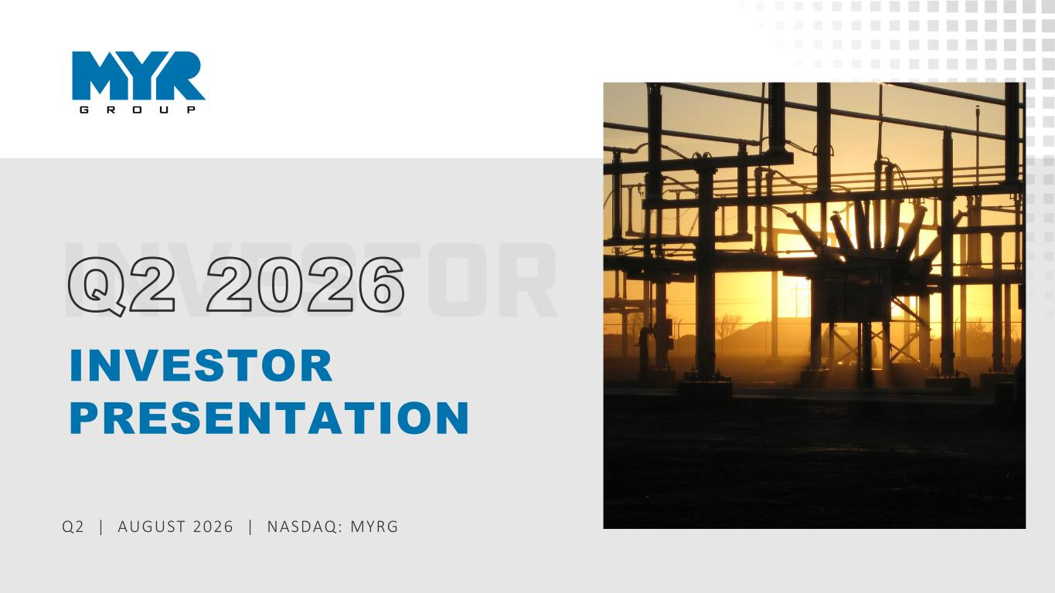
-3-
1 Q2 | AUGUST 2026 | NASDAQ: MYRG INVESTOR PRESENTATION Q2 2026

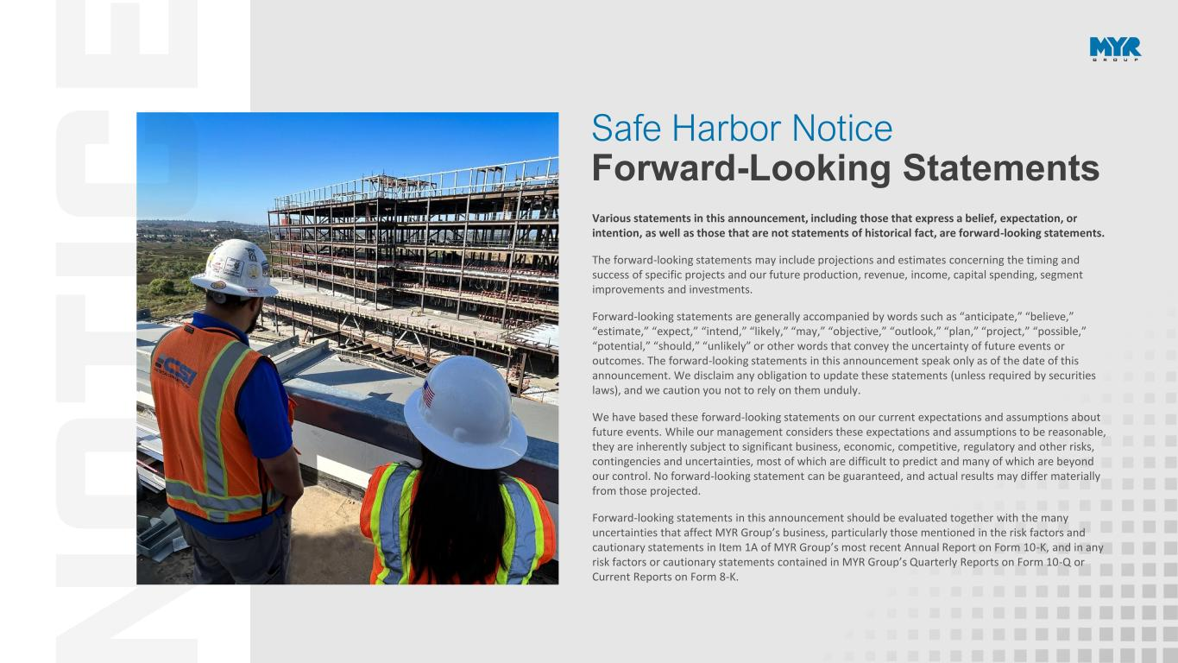
2 Various statements in this announcement, including those that express a belief, expectation, or intention, as well as those that are not statements of historical fact, are forward-looking statements. The forward-looking statements may include projections and estimates concerning the timing and success of specific projects and our future production, revenue, income, capital spending, segment improvements and investments. Forward-looking statements are generally accompanied by words such as “anticipate,” “believe,” “estimate,” “expect,” “intend,” “likely,” “may,” “objective,” “outlook,” “plan,” “project,” “possible,” “potential,” “should,” “unlikely” or other words that convey the uncertainty of future events or outcomes. The forward-looking statements in this announcement speak only as of the date of this announcement. We disclaim any obligation to update these statements (unless required by securities laws), and we caution you not to rely on them unduly. We have based these forward-looking statements on our current expectations and assumptions about future events. While our management considers these expectations and assumptions to be reasonable, they are inherently subject to significant business, economic, competitive, regulatory and other risks, contingencies and uncertainties, most of which are difficult to predict and many of which are beyond our control. No forward-looking statement can be guaranteed, and actual results may differ materially from those projected. Forward-looking statements in this announcement should be evaluated together with the many uncertainties that affect MYR Group’s business, particularly those mentioned in the risk factors and cautionary statements in Item 1A of MYR Group’s most recent Annual Report on Form 10-K, and in any risk factors or cautionary statements contained in MYR Group’s Quarterly Reports on Form 10-Q or Current Reports on Form 8-K. Safe Harbor Notice Forward-Looking Statements

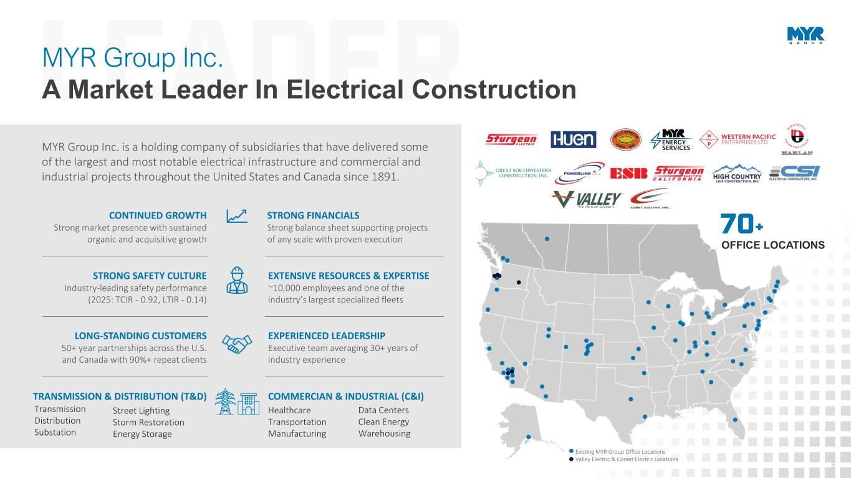
3 MYR Group Inc. A Market Leader In Electrical Construction MYR Group Inc. is a holding company of subsidiaries that have delivered some of the largest and most notable electrical infrastructure and commercial and industrial projects throughout the United States and Canada since 1891. STRONG FINANCIALS Strong balance sheet supporting projects of any scale with proven execution EXTENSIVE RESOURCES & EXPERTISE ~10,000 employees and one of the industry’s largest specialized fleets COMMERCIAN & INDUSTRIAL (C&I) EXPERIENCED LEADERSHIP Executive team averaging 30+ years of industry experience CONTINUED GROWTH Strong market presence with sustained organic and acquisitive growth STRONG SAFETY CULTURE Industry-leading safety performance (2025: TCIR - 0.92, LTIR - 0.14) LONG-STANDING CUSTOMERS 50+ year partnerships across the U.S. and Canada with 90%+ repeat clients TRANSMISSION & DISTRIBUTION (T&D) Transmission Distribution Substation Street Lighting Storm Restoration Energy Storage Healthcare Transportation Manufacturing Data Centers Clean Energy Warehousing 70+ OFFICE LOCATIONS Existing MYR Group Office Locations Valley Electric & Comet Electric Locations

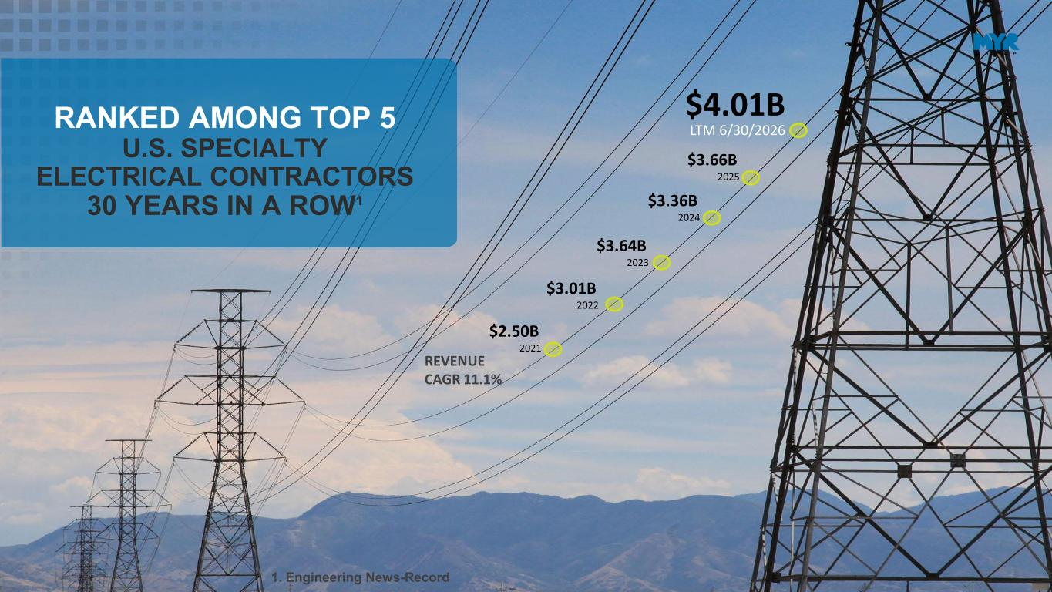
4 $4.01B LTM 6/30/2026 $2.50B 2021 $3.01B 2022 $3.66B 2025 $3.64B 2023 REVENUE CAGR 11.1% RANKED AMONG TOP 5 U.S. SPECIALTY ELECTRICAL CONTRACTORS 30 YEARS IN A ROW1 $3.36B 2024 1. Engineering News-Record

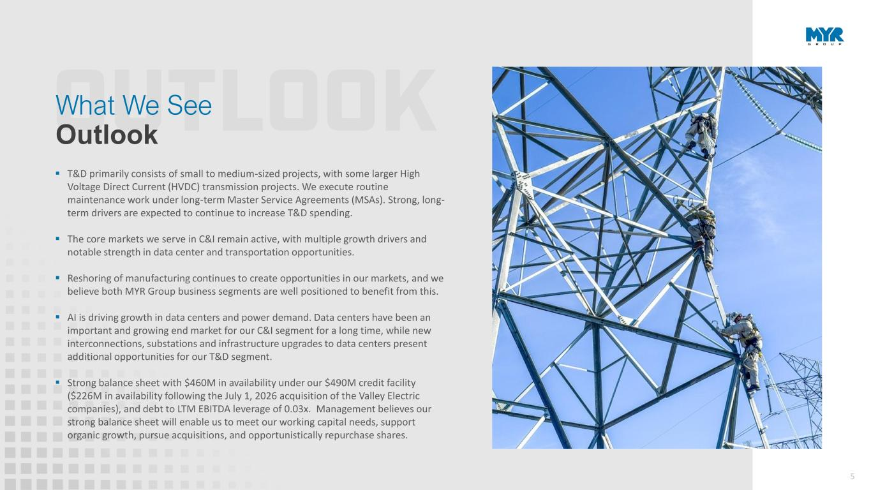
5 ▪ T&D primarily consists of small to medium-sized projects, with some larger High Voltage Direct Current (HVDC) transmission projects. We execute routine maintenance work under long-term Master Service Agreements (MSAs). Strong, long- term drivers are expected to continue to increase T&D spending. ▪ The core markets we serve in C&I remain active, with multiple growth drivers and notable strength in data center and transportation opportunities. ▪ Reshoring of manufacturing continues to create opportunities in our markets, and we believe both MYR Group business segments are well positioned to benefit from this. ▪ AI is driving growth in data centers and power demand. Data centers have been an important and growing end market for our C&I segment for a long time, while new interconnections, substations and infrastructure upgrades to data centers present additional opportunities for our T&D segment. ▪ Strong balance sheet with $460M in availability under our $490M credit facility ($226M in availability following the July 1, 2026 acquisition of the Valley Electric companies), and debt to LTM EBITDA leverage of 0.03x. Management believes our strong balance sheet will enable us to meet our working capital needs, support organic growth, pursue acquisitions, and opportunistically repurchase shares. What We See Outlook

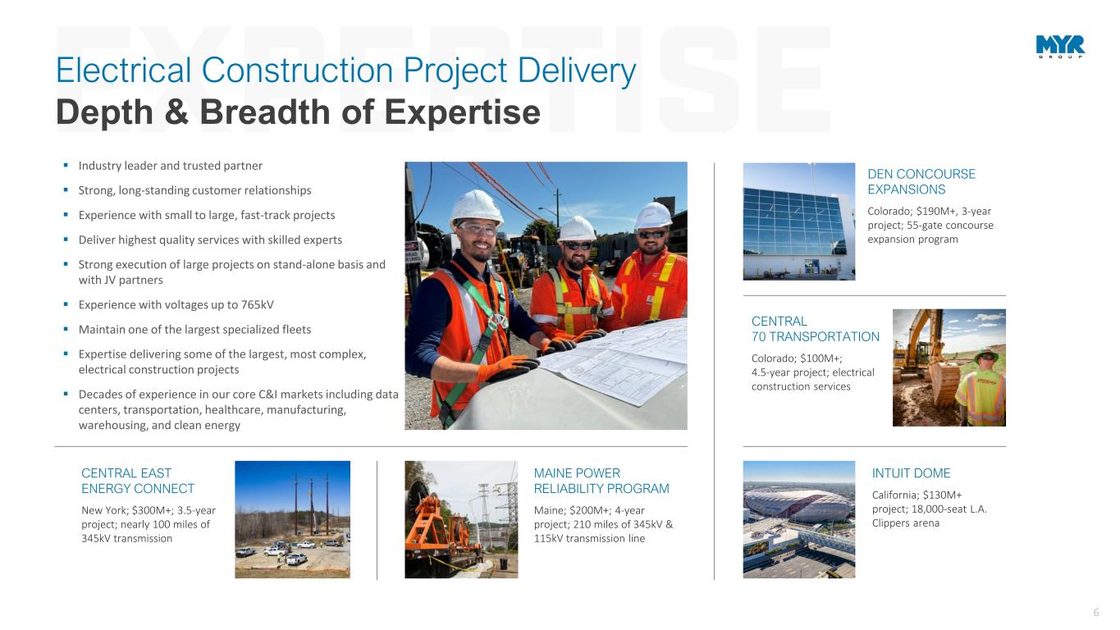
6 A person in a safety vest and helmet looking at a construction vehicle Description automatically generated MAINE POWER RELIABILITY PROGRAM Maine; $200M+; 4-year project; 210 miles of 345kV & 115kV transmission line CENTRAL 70 TRANSPORTATION Colorado; $100M+; 4.5-year project; electrical construction services CENTRAL EAST ENERGY CONNECT New York; $300M+; 3.5-year project; nearly 100 miles of 345kV transmission DEN CONCOURSE EXPANSIONS Colorado; $190M+, 3-year project; 55-gate concourse expansion program ▪ Industry leader and trusted partner ▪ Strong, long-standing customer relationships ▪ Experience with small to large, fast-track projects ▪ Deliver highest quality services with skilled experts ▪ Strong execution of large projects on stand-alone basis and with JV partners ▪ Experience with voltages up to 765kV ▪ Maintain one of the largest specialized fleets ▪ Expertise delivering some of the largest, most complex, electrical construction projects ▪ Decades of experience in our core C&I markets including data centers, transportation, healthcare, manufacturing, warehousing, and clean energy Electrical Construction Project Delivery Depth & Breadth of Expertise INTUIT DOME California; $130M+ project; 18,000-seat L.A. Clippers arena

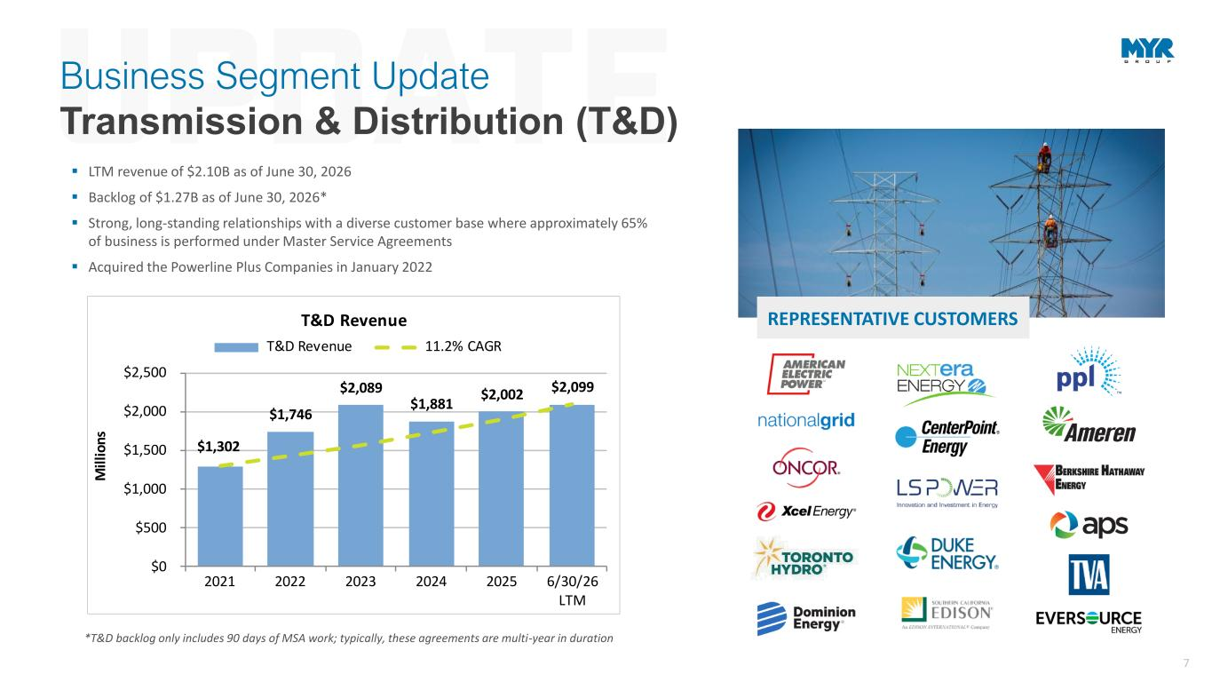
7 ▪ LTM revenue of $2.10B as of June 30, 2026 ▪ Backlog of $1.27B as of June 30, 2026* ▪ Strong, long-standing relationships with a diverse customer base where approximately 65% of business is performed under Master Service Agreements ▪ Acquired the Powerline Plus Companies in January 2022 REPRESENTATIVE CUSTOMERS *T&D backlog only includes 90 days of MSA work; typically, these agreements are multi-year in duration $1,302 $1,746 $2,089 $1,881 $2,002 $2,099 $0 $500 $1,000 $1,500 $2,000 $2,500 2021 2022 2023 2024 2025 6/30/26 LTM M ill io ns T&D Revenue T&D Revenue 11.2% CAGR Business Segment Update Transmission & Distribution (T&D)

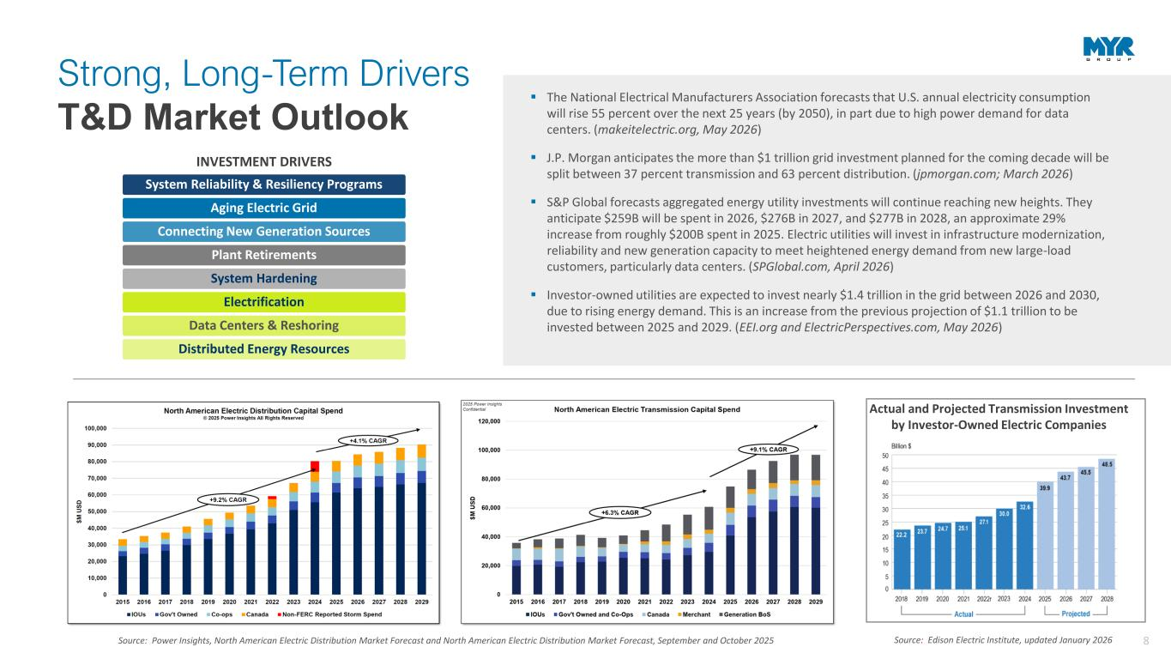
8Source: Power Insights, North American Electric Distribution Market Forecast and North American Electric Distribution Market Forecast, September and October 2025 Source: Edison Electric Institute, updated January 2026 Actual and Projected Transmission Investment by Investor-Owned Electric Companies ▪ The National Electrical Manufacturers Association forecasts that U.S. annual electricity consumption will rise 55 percent over the next 25 years (by 2050), in part due to high power demand for data centers. (makeitelectric.org, May 2026) ▪ J.P. Morgan anticipates the more than $1 trillion grid investment planned for the coming decade will be split between 37 percent transmission and 63 percent distribution. (jpmorgan.com; March 2026) ▪ S&P Global forecasts aggregated energy utility investments will continue reaching new heights. They anticipate $259B will be spent in 2026, $276B in 2027, and $277B in 2028, an approximate 29% increase from roughly $200B spent in 2025. Electric utilities will invest in infrastructure modernization, reliability and new generation capacity to meet heightened energy demand from new large-load customers, particularly data centers. (SPGlobal.com, April 2026) ▪ Investor-owned utilities are expected to invest nearly $1.4 trillion in the grid between 2026 and 2030, due to rising energy demand. This is an increase from the previous projection of $1.1 trillion to be invested between 2025 and 2029. (EEI.org and ElectricPerspectives.com, May 2026) System Reliability & Resiliency Programs Aging Electric Grid Connecting New Generation Sources Plant Retirements System Hardening Electrification Data Centers & Reshoring Distributed Energy Resources INVESTMENT DRIVERS Strong, Long-Term Drivers T&D Market Outlook

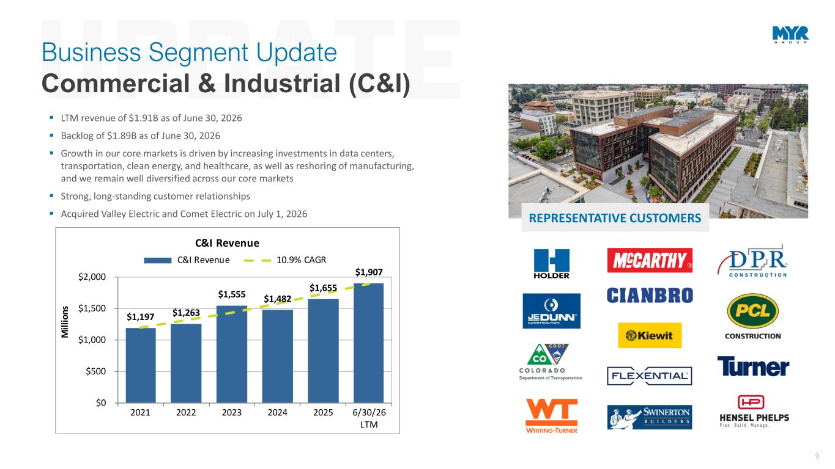
9 REPRESENTATIVE CUSTOMERS $1,197 $1,263 $1,555 $1,482 $1,655 $1,907 $0 $500 $1,000 $1,500 $2,000 2021 2022 2023 2024 2025 6/30/26 LTM M il li on s C&I Revenue C&I Revenue 10.9% CAGR Business Segment Update Commercial & Industrial (C&I) ▪ LTM revenue of $1.91B as of June 30, 2026 ▪ Backlog of $1.89B as of June 30, 2026 ▪ Growth in our core markets is driven by increasing investments in data centers, transportation, clean energy, and healthcare, as well as reshoring of manufacturing, and we remain well diversified across our core markets ▪ Strong, long-standing customer relationships ▪ Acquired Valley Electric and Comet Electric on July 1, 2026

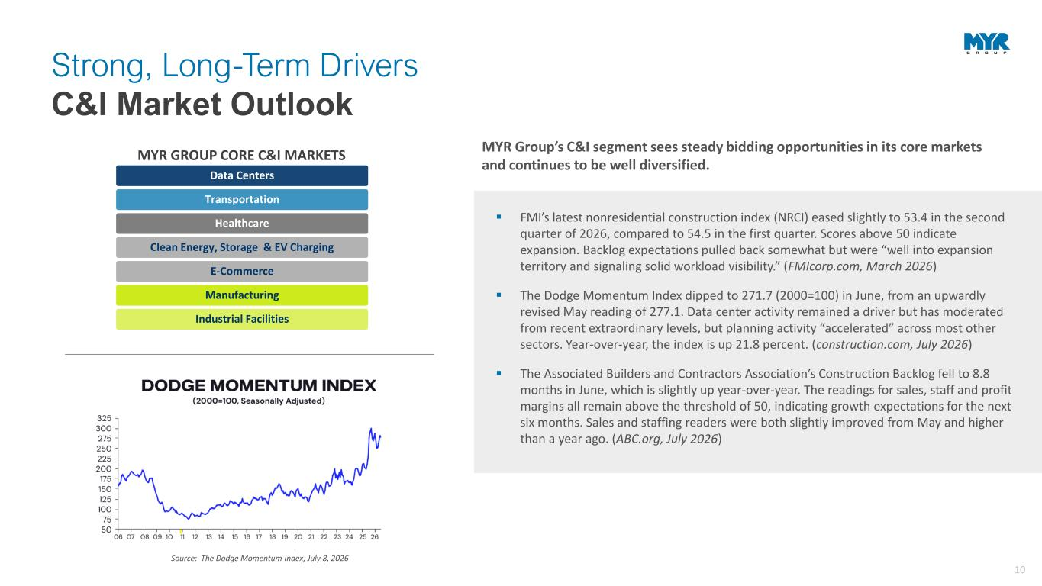
10 Data Centers Transportation Healthcare Clean Energy, Storage & EV Charging E-Commerce Manufacturing Industrial Facilities MYR GROUP CORE C&I MARKETS ▪ FMI’s latest nonresidential construction index (NRCI) eased slightly to 53.4 in the second quarter of 2026, compared to 54.5 in the first quarter. Scores above 50 indicate expansion. Backlog expectations pulled back somewhat but were “well into expansion territory and signaling solid workload visibility.” (FMIcorp.com, March 2026) ▪ The Dodge Momentum Index dipped to 271.7 (2000=100) in June, from an upwardly revised May reading of 277.1. Data center activity remained a driver but has moderated from recent extraordinary levels, but planning activity “accelerated” across most other sectors. Year-over-year, the index is up 21.8 percent. (construction.com, July 2026) ▪ The Associated Builders and Contractors Association’s Construction Backlog fell to 8.8 months in June, which is slightly up year-over-year. The readings for sales, staff and profit margins all remain above the threshold of 50, indicating growth expectations for the next six months. Sales and staffing readers were both slightly improved from May and higher than a year ago. (ABC.org, July 2026) Source: The Dodge Momentum Index, July 8, 2026 MYR Group’s C&I segment sees steady bidding opportunities in its core markets and continues to be well diversified. Strong, Long-Term Drivers C&I Market Outlook

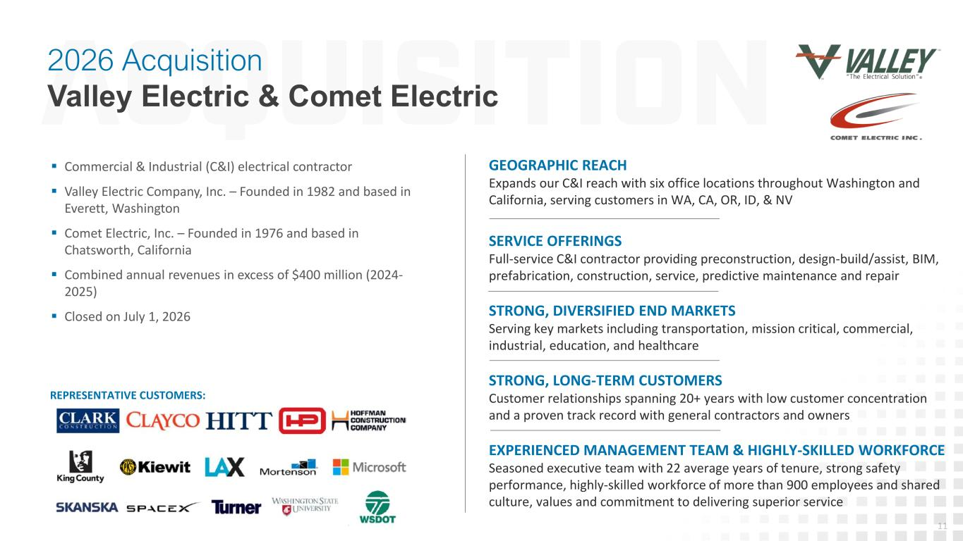
11 ▪ Commercial & Industrial (C&I) electrical contractor ▪ Valley Electric Company, Inc. – Founded in 1982 and based in Everett, Washington ▪ Comet Electric, Inc. – Founded in 1976 and based in Chatsworth, California ▪ Combined annual revenues in excess of $400 million (2024- 2025) ▪ Closed on July 1, 2026 2026 Acquisition Valley Electric & Comet Electric GEOGRAPHIC REACH Expands our C&I reach with six office locations throughout Washington and California, serving customers in WA, CA, OR, ID, & NV SERVICE OFFERINGS Full-service C&I contractor providing preconstruction, design-build/assist, BIM, prefabrication, construction, service, predictive maintenance and repair STRONG, DIVERSIFIED END MARKETS Serving key markets including transportation, mission critical, commercial, industrial, education, and healthcare STRONG, LONG-TERM CUSTOMERS Customer relationships spanning 20+ years with low customer concentration and a proven track record with general contractors and owners EXPERIENCED MANAGEMENT TEAM & HIGHLY-SKILLED WORKFORCE Seasoned executive team with 22 average years of tenure, strong safety performance, highly-skilled workforce of more than 900 employees and shared culture, values and commitment to delivering superior service REPRESENTATIVE CUSTOMERS:

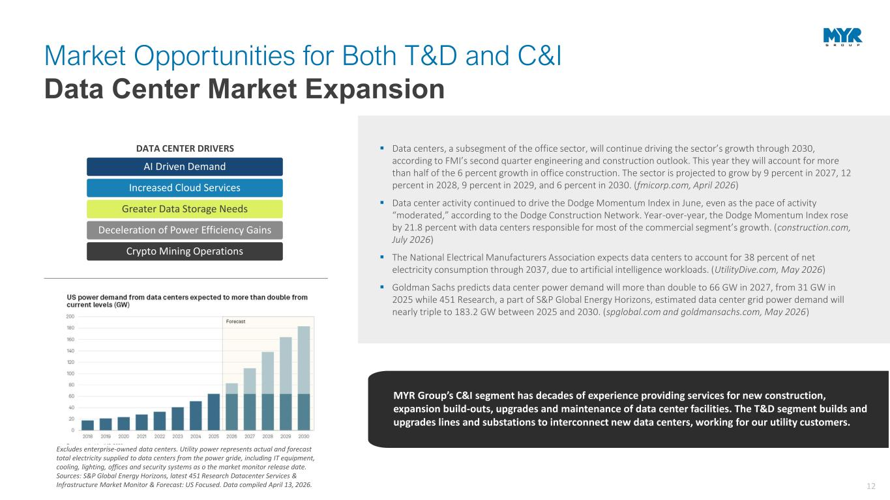
12 AI Driven Demand Increased Cloud Services Greater Data Storage Needs Deceleration of Power Efficiency Gains Crypto Mining Operations DATA CENTER DRIVERS ▪ Data centers, a subsegment of the office sector, will continue driving the sector’s growth through 2030, according to FMI’s second quarter engineering and construction outlook. This year they will account for more than half of the 6 percent growth in office construction. The sector is projected to grow by 9 percent in 2027, 12 percent in 2028, 9 percent in 2029, and 6 percent in 2030. (fmicorp.com, April 2026) ▪ Data center activity continued to drive the Dodge Momentum Index in June, even as the pace of activity “moderated,” according to the Dodge Construction Network. Year-over-year, the Dodge Momentum Index rose by 21.8 percent with data centers responsible for most of the commercial segment’s growth. (construction.com, July 2026) ▪ The National Electrical Manufacturers Association expects data centers to account for 38 percent of net electricity consumption through 2037, due to artificial intelligence workloads. (UtilityDive.com, May 2026) ▪ Goldman Sachs predicts data center power demand will more than double to 66 GW in 2027, from 31 GW in 2025 while 451 Research, a part of S&P Global Energy Horizons, estimated data center grid power demand will nearly triple to 183.2 GW between 2025 and 2030. (spglobal.com and goldmansachs.com, May 2026) MYR Group’s C&I segment has decades of experience providing services for new construction, expansion build-outs, upgrades and maintenance of data center facilities. The T&D segment builds and upgrades lines and substations to interconnect new data centers, working for our utility customers. Market Opportunities for Both T&D and C&I Data Center Market Expansion Excludes enterprise-owned data centers. Utility power represents actual and forecast total electricity supplied to data centers from the power gride, including IT equipment, cooling, lighting, offices and security systems as o the market monitor release date. Sources: S&P Global Energy Horizons, latest 451 Research Datacenter Services & Infrastructure Market Monitor & Forecast: US Focused. Data compiled April 13, 2026.

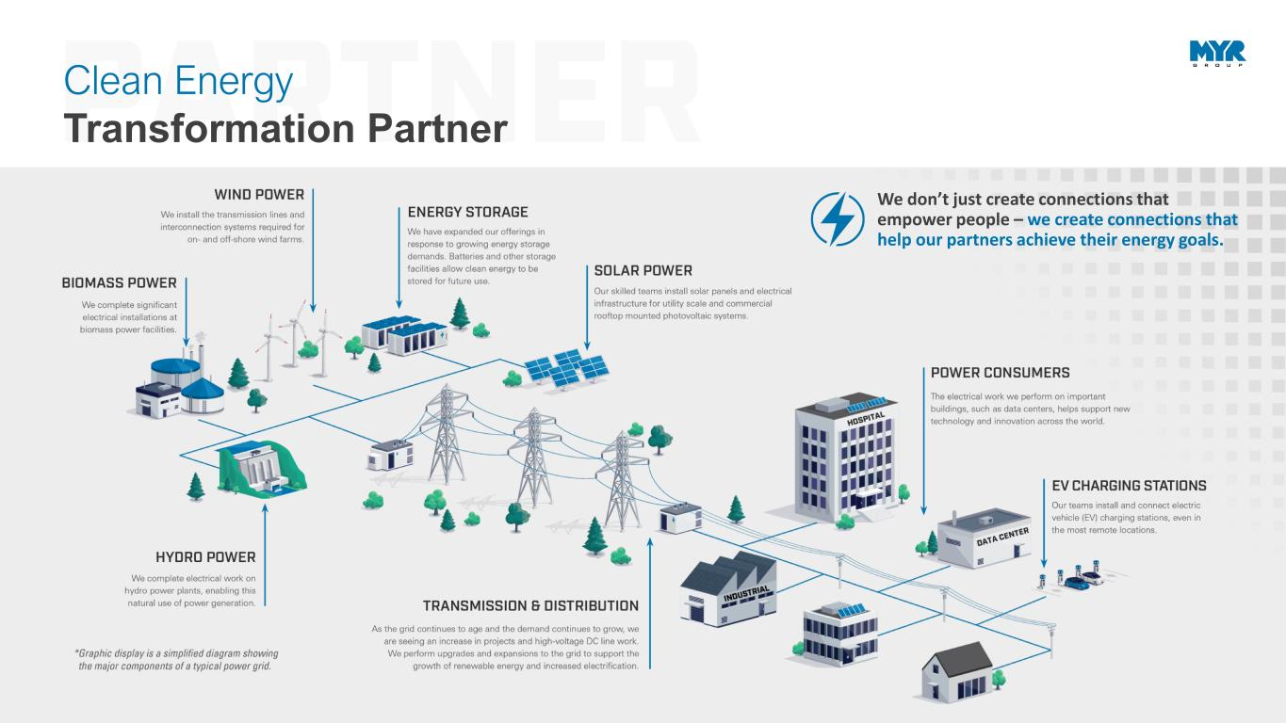
13 We don’t just create connections that empower people – we create connections that help our partners achieve their energy goals. Clean Energy Transformation Partner

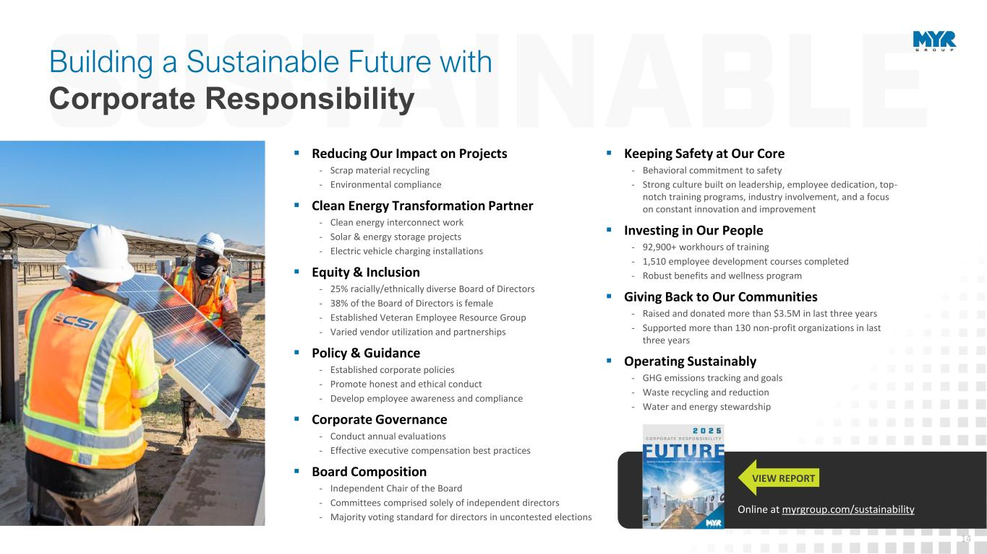
14 VIEW REPORT ▪ Reducing Our Impact on Projects - Scrap material recycling - Environmental compliance ▪ Clean Energy Transformation Partner - Clean energy interconnect work - Solar & energy storage projects - Electric vehicle charging installations ▪ Equity & Inclusion - 25% racially/ethnically diverse Board of Directors - 38% of the Board of Directors is female - Established Veteran Employee Resource Group - Varied vendor utilization and partnerships ▪ Policy & Guidance - Established corporate policies - Promote honest and ethical conduct - Develop employee awareness and compliance ▪ Corporate Governance - Conduct annual evaluations - Effective executive compensation best practices ▪ Board Composition - Independent Chair of the Board - Committees comprised solely of independent directors - Majority voting standard for directors in uncontested elections ▪ Keeping Safety at Our Core - Behavioral commitment to safety - Strong culture built on leadership, employee dedication, top- notch training programs, industry involvement, and a focus on constant innovation and improvement ▪ Investing in Our People - 92,900+ workhours of training - 1,510 employee development courses completed - Robust benefits and wellness program ▪ Giving Back to Our Communities - Raised and donated more than $3.5M in last three years - Supported more than 130 non-profit organizations in last three years ▪ Operating Sustainably - GHG emissions tracking and goals - Waste recycling and reduction - Water and energy stewardship Online at myrgroup.com/sustainability Building a Sustainable Future with Corporate Responsibility

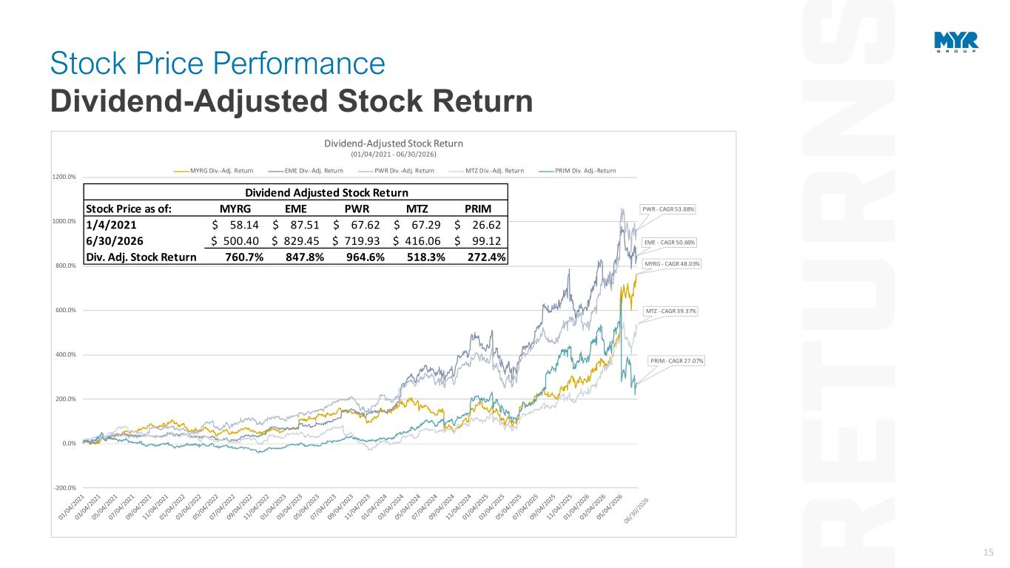
15 MYRG - CAGR 48.03% EME - CAGR 50.66% PWR - CAGR 53.88% MTZ - CAGR 39.37% PRIM - CAGR 27.07% -200.0% 0.0% 200.0% 400.0% 600.0% 800.0% 1000.0% 1200.0% Dividend-Adjusted Stock Return (01/04/2021 - 06/30/2026) MYRG Div.-Adj. Return EME Div.-Adj. Return PWR Div.-Adj. Return MTZ Div.-Adj. Return PRIM Div. Adj.-Return Dividend Adjusted Stock Return Stock Price as of: MYRG EME PWR MTZ PRIM 1/4/2021 58.14$ 87.51$ 67.62$ 67.29$ 26.62$ 6/30/2026 500.40$ 829.45$ 719.93$ 416.06$ 99.12$ Div. Adj. Stock Return 760.7% 847.8% 964.6% 518.3% 272.4% Stock Price Performance Dividend-Adjusted Stock Return

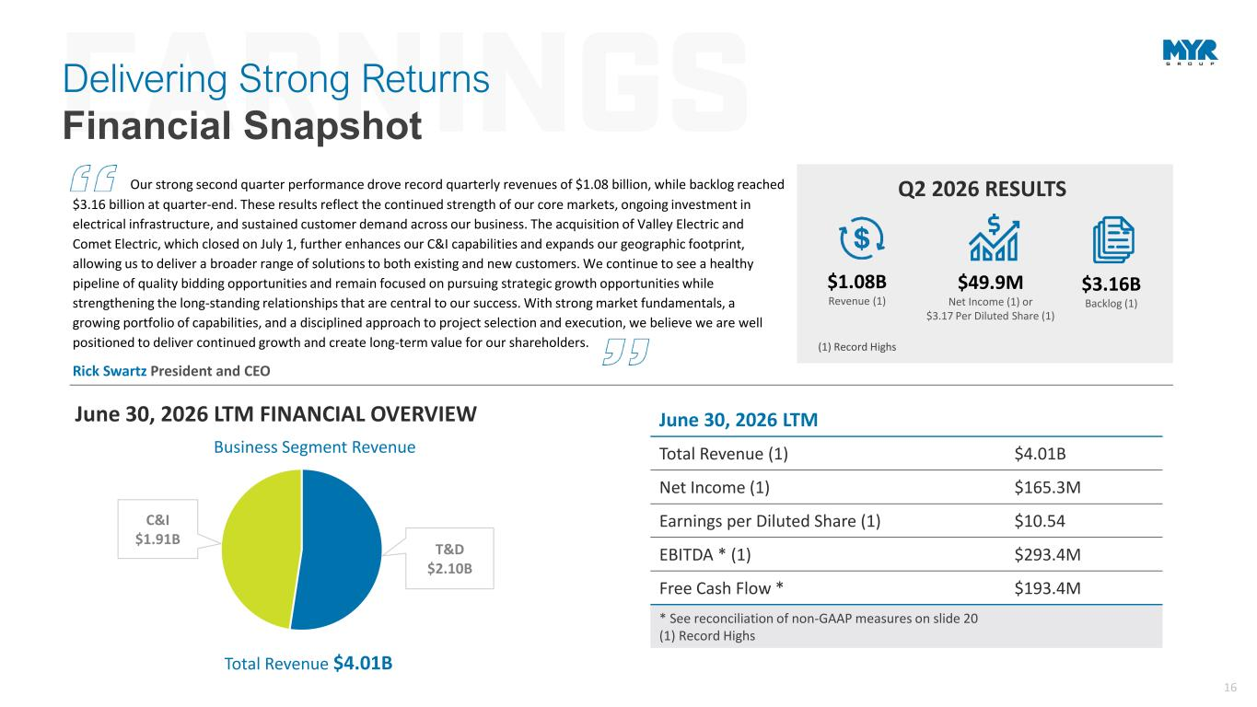
16 T&D $2.10B C&I $1.91B Business Segment Revenue Q2 2026 RESULTS $49.9M Net Income (1) or $3.17 Per Diluted Share (1) $3.16B Backlog (1) $1.08B Revenue (1) Our strong second quarter performance drove record quarterly revenues of $1.08 billion, while backlog reached $3.16 billion at quarter-end. These results reflect the continued strength of our core markets, ongoing investment in electrical infrastructure, and sustained customer demand across our business. The acquisition of Valley Electric and Comet Electric, which closed on July 1, further enhances our C&I capabilities and expands our geographic footprint, allowing us to deliver a broader range of solutions to both existing and new customers. We continue to see a healthy pipeline of quality bidding opportunities and remain focused on pursuing strategic growth opportunities while strengthening the long-standing relationships that are central to our success. With strong market fundamentals, a growing portfolio of capabilities, and a disciplined approach to project selection and execution, we believe we are well positioned to deliver continued growth and create long-term value for our shareholders. Rick Swartz President and CEO June 30, 2026 LTM Total Revenue (1) $4.01B Net Income (1) $165.3M Earnings per Diluted Share (1) $10.54 EBITDA * (1) $293.4M Free Cash Flow * $193.4M * See reconciliation of non-GAAP measures on slide 20 (1) Record Highs June 30, 2026 LTM FINANCIAL OVERVIEW Total Revenue $4.01B (1) Record Highs Delivering Strong Returns Financial Snapshot

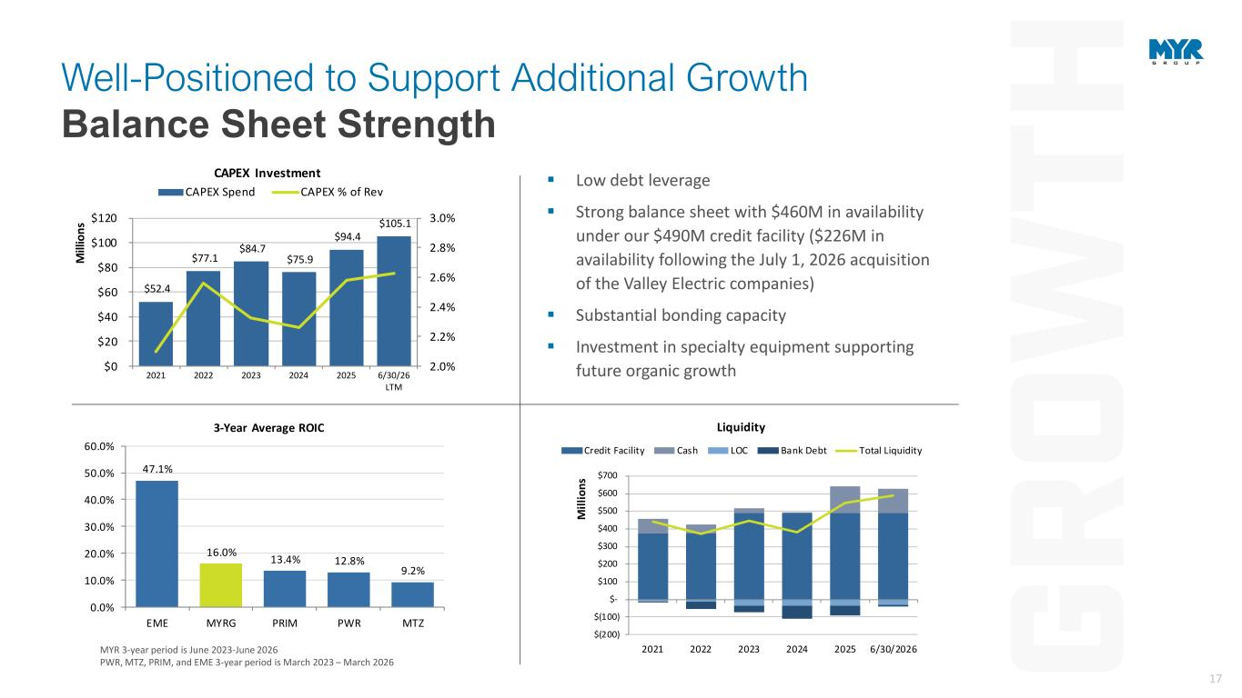
17 47.1% 16.0% 13.4% 12.8% 9.2% 0.0% 10.0% 20.0% 30.0% 40.0% 50.0% 60.0% EME MYRG PRIM PWR MTZ 3-Year Average ROIC MYR 3-year period is June 2023-June 2026 PWR, MTZ, PRIM, and EME 3-year period is March 2023 – March 2026 ▪ Low debt leverage ▪ Strong balance sheet with $460M in availability under our $490M credit facility ($226M in availability following the July 1, 2026 acquisition of the Valley Electric companies) ▪ Substantial bonding capacity ▪ Investment in specialty equipment supporting future organic growth $52.4 $77.1 $84.7 $75.9 $94.4 $105.1 2.0% 2.2% 2.4% 2.6% 2.8% 3.0% $0 $20 $40 $60 $80 $100 $120 2021 2022 2023 2024 2025 6/30/26 LTM M ill io n s CAPEX Investment CAPEX Spend CAPEX % of Rev $(200) $(100) $- $100 $200 $300 $400 $500 $600 $700 2021 2022 2023 2024 2025 6/30/2026 M il li o n s Liquidity Credit Facility Cash LOC Bank Debt Total Liquidity Well-Positioned to Support Additional Growth Balance Sheet Strength

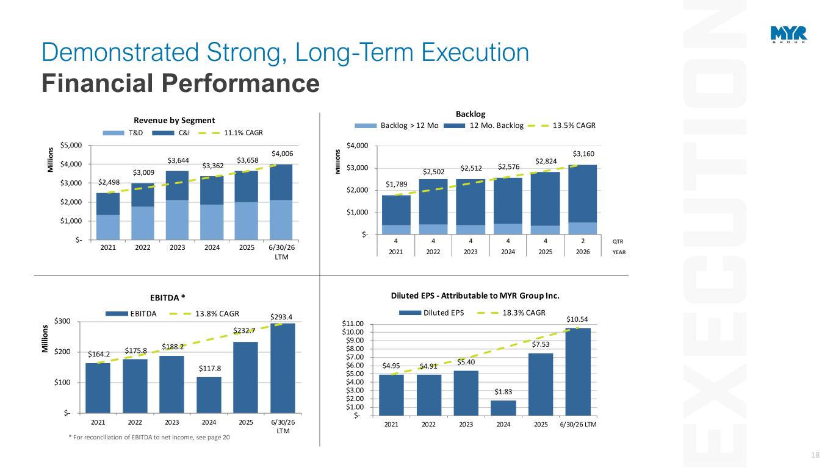
18 $164.2 $175.8 $188.2 $117.8 $232.7 $293.4 $- $100 $200 $300 2021 2022 2023 2024 2025 6/30/26 LTM M ill io n s EBITDA * EBITDA 13.8% CAGR * For reconciliation of EBITDA to net income, see page 20 QTR YEAR $1,789 $2,502 $2,512 $2,576 $2,824 $3,160 $- $1,000 $2,000 $3,000 $4,000 4 4 4 4 4 2 2021 2022 2023 2024 2025 2026 M ill io ns Backlog Backlog > 12 Mo 12 Mo. Backlog 13.5% CAGR $4.95 $4.91 $5.40 $1.83 $7.53 $10.54 $- $1.00 $2.00 $3.00 $4.00 $5.00 $6.00 $7.00 $8.00 $9.00 $10.00 $11.00 2021 2022 2023 2024 2025 6/30/26 LTM Diluted EPS - Attributable to MYR Group Inc. Diluted EPS 18.3% CAGR Demonstrated Strong, Long-Term Execution Financial Performance $2,498 $3,009 $3,644 $3,362 $3,658 $4,006 $- $1,000 $2,000 $3,000 $4,000 $5,000 2021 2022 2023 2024 2025 6/30/26 LTM M ill io n s Revenue by Segment T&D C&I 11.1% CAGR

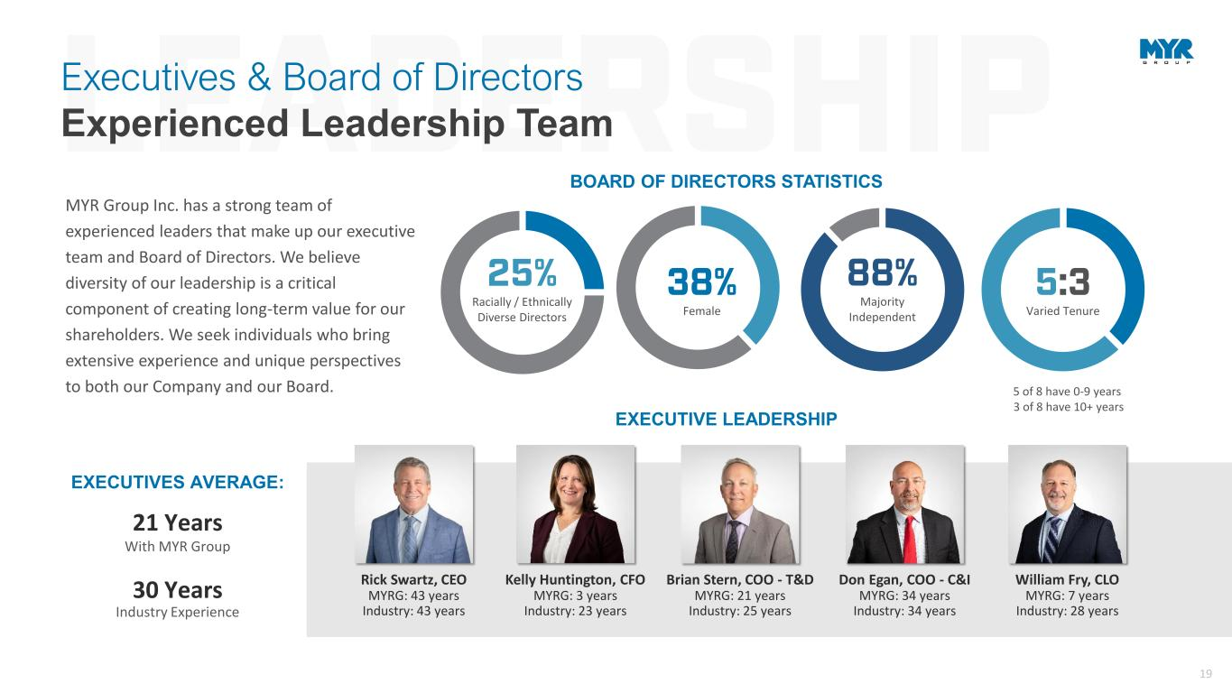
19 EXECUTIVE LEADERSHIP Rick Swartz, CEO MYRG: 43 years Industry: 43 years 21 Years EXECUTIVES AVERAGE: With MYR Group MYR Group Inc. has a strong team of experienced leaders that make up our executive team and Board of Directors. We believe diversity of our leadership is a critical component of creating long-term value for our shareholders. We seek individuals who bring extensive experience and unique perspectives to both our Company and our Board. 30 Years Industry Experience BOARD OF DIRECTORS STATISTICS 38% Female 88% Majority Independent 25% Racially / Ethnically Diverse Directors 5:3 Varied Tenure 5 of 8 have 0-9 years 3 of 8 have 10+ years Executives & Board of Directors Experienced Leadership Team Kelly Huntington, CFO MYRG: 3 years Industry: 23 years Brian Stern, COO - T&D MYRG: 21 years Industry: 25 years Don Egan, COO - C&I MYRG: 34 years Industry: 34 years William Fry, CLO MYRG: 7 years Industry: 28 years

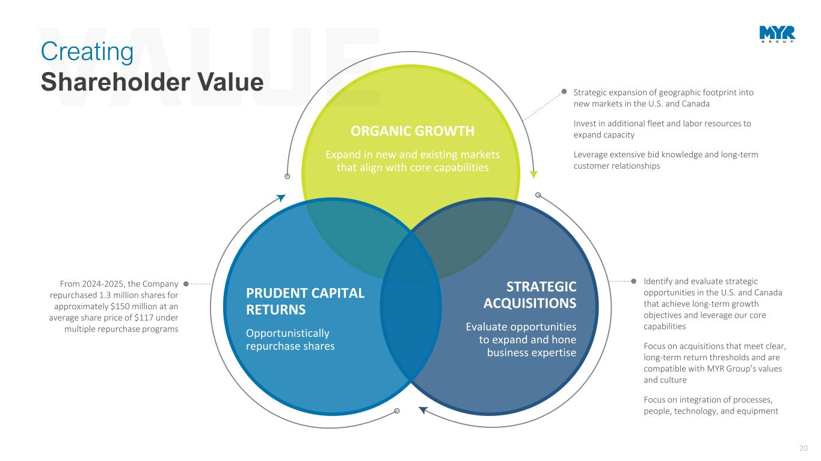
20 Identify and evaluate strategic opportunities in the U.S. and Canada that achieve long-term growth objectives and leverage our core capabilities Focus on acquisitions that meet clear, long-term return thresholds and are compatible with MYR Group’s values and culture Focus on integration of processes, people, technology, and equipment Strategic expansion of geographic footprint into new markets in the U.S. and Canada Invest in additional fleet and labor resources to expand capacity Leverage extensive bid knowledge and long-term customer relationships ORGANIC GROWTH Expand in new and existing markets that align with core capabilities STRATEGIC ACQUISITIONS Evaluate opportunities to expand and hone business expertise PRUDENT CAPITAL RETURNS Opportunistically repurchase shares From 2024-2025, the Company repurchased 1.3 million shares for approximately $150 million at an average share price of $117 under multiple repurchase programs Creating Shareholder Value

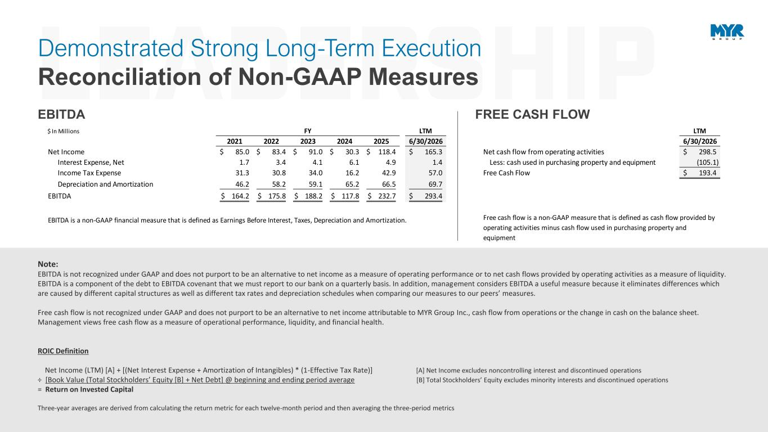
21 Demonstrated Strong Long-Term Execution Reconciliation of Non-GAAP Measures Note: EBITDA is not recognized under GAAP and does not purport to be an alternative to net income as a measure of operating performance or to net cash flows provided by operating activities as a measure of liquidity. EBITDA is a component of the debt to EBITDA covenant that we must report to our bank on a quarterly basis. In addition, management considers EBITDA a useful measure because it eliminates differences which are caused by different capital structures as well as different tax rates and depreciation schedules when comparing our measures to our peers’ measures. Free cash flow is not recognized under GAAP and does not purport to be an alternative to net income attributable to MYR Group Inc., cash flow from operations or the change in cash on the balance sheet. Management views free cash flow as a measure of operational performance, liquidity, and financial health. ROIC Definition Net Income (LTM) [A] + [(Net Interest Expense + Amortization of Intangibles) * (1-Effective Tax Rate)] [A] Net Income excludes noncontrolling interest and discontinued operations ÷ [Book Value (Total Stockholders’ Equity [B] + Net Debt] @ beginning and ending period average [B] Total Stockholders’ Equity excludes minority interests and discontinued operations = Return on Invested Capital Three-year averages are derived from calculating the return metric for each twelve-month period and then averaging the three-period metrics EBITDA FREE CASH FLOW $ In Millions FY LTM LTM 2021 2022 2023 2024 2025 6/30/2026 6/30/2026 Net Income 85.0$ 83.4$ 91.0$ 30.3$ 118.4$ 165.3$ Net cash flow from operating activities 298.5$ Interest Expense, Net 1.7 3.4 4.1 6.1 4.9 1.4 Less: cash used in purchasing property and equipment (105.1) Income Tax Expense 31.3 30.8 34.0 16.2 42.9 57.0 Free Cash Flow 193.4$ Depreciation and Amortization 46.2 58.2 59.1 65.2 66.5 69.7 EBITDA 164.2$ 175.8$ 188.2$ 117.8$ 232.7$ 293.4$ EBITDA is a non-GAAP financial measure that is defined as Earnings Before Interest, Taxes, Depreciation and Amortization. Free cash flow is a non-GAAP measure that is defined as cash flow provided by operating activities minus cash flow used in purchasing property and equipment

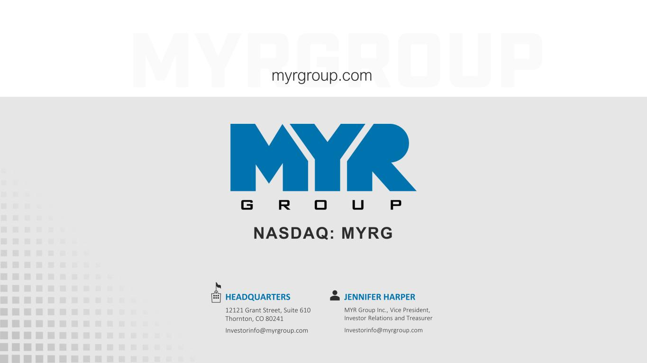
22 NASDAQ: MYRG myrgroup.com JENNIFER HARPER MYR Group Inc., Vice President, Investor Relations and Treasurer Investorinfo@myrgroup.com HEADQUARTERS 12121 Grant Street, Suite 610 Thornton, CO 80241 Investorinfo@myrgroup.com

